**ASSIGNMENT 2.1**

**Task 1**

Directory /user/acadgild was present in the machine. But no Hadoop directory was present.

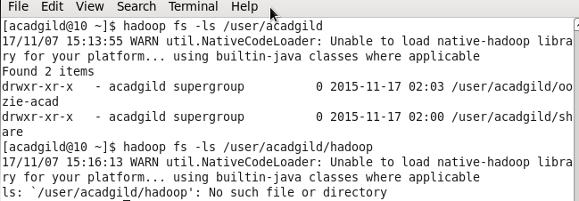

Created Hadoop directory under /user/acadgild

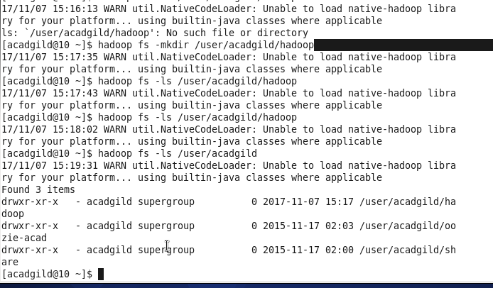

**Task 2**

Created file in local and copied it in Hadoop.

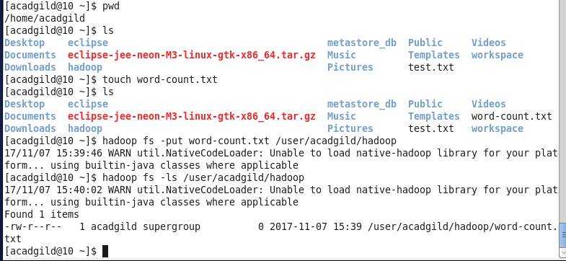

Appended the file

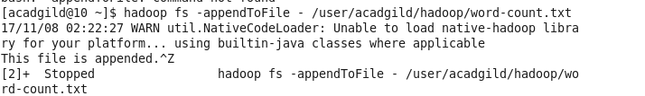

Used Ctrl + D to save the appended text.

After running “cat” command we can see the appended text.

